OKLAHOMA BUSINESS ETHICS CONSORTIUM
Oklahoma City Chapter ~ July 9, 2008
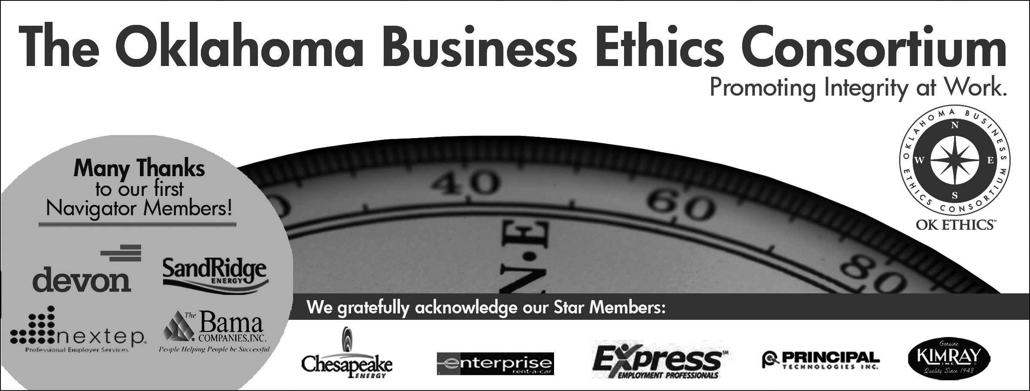
VISION: To be recognized as a statewide (and national)
forum for promoting business ethics.

- KUDOS & WELCOME

  - Bobby Redinger of Cole & Reed – We commend her flexibility in accommodating our late requests for revisions and photocopying the agendas.
  - Greg Byers of Sinclair Broadcasting Group – Greg is THE most dependable person! We appreciate his strong stewardship and dedication as our Registration Chairperson.
  - Mary Kay Huggard & the Principal Technologies team provide great service to all our members. They make sure that everyone is greeted with friendliness and that the registration always goes smoothly.
  - Joshua Jantz of the Institute of Basic Life Principles is a living example of a servant’s heart. Thank you for providing our monthly name tags.
  - Connie Barwick – Maximum Multi Media Creations for the pre-meeting Power Point presentations and website.(A special “hats off” as her son joined the Marine Corps on Monday. We are proud of Connie and her family!)
  - Brent Gooden of The Gooden Group for his initiative in making today’s event possible.
  - Kellian Schneider of Full Force Branding – Honoree at Journal Record’s first Beacon Awards for her wonderful donation of service. Kelli is responsible for, among many things, OkEthics new website and logo. She designed our Compass Awards program and has been an outstanding contributor to this organization. At the banquet tomorrow night, Kelli will be recognized as a finalist for her dedication to the community and OkEthics. We are deeply grateful and honored to have Kelli serve on OkEthics’ Board of Directors.
  - Welcome The Hertz Corporation as OkEthics newest HORIZON member!
  - Behind the scenes, our dedicated volunteers who serve on the Board and are the heart of this organization!

- GUIDING PRINCIPLE Shannon Warren, Founder, OkEthics

Honor:
Realizing that each of us is in a mode of continual learning, we demonstrate humility, care and compassion when sharing our thoughts and knowledge.

What is humility anyway? Penny Hampton, Consultant, OCCC

III. INTRODUCTION OF GUEST SPEAKER Brent Gooden, The Gooden Group

General Disclaimer: Members of the Oklahoma Business Ethics Consortium frequently share information concerning various issues and developments that may have legal implications. The discussions, commentary, and handouts at Consortium meetings or presentations to other organizations are for general informational purposes only. They cover only some aspects of the subject topic, and do not constitute a complete legal analysis of the topic or how it might apply to any particular set of facts. Before taking any action based on information presented during a Consortium event, participants are encouraged to consult a qualified attorney. The observations and comments of presenters at Consortium meetings and networking are the views and opinions of the presenter and do not constitute the opinion or policies of the Consortium or any of its members. Presenters are respectfully requested to avoid profanity, preaching, politics and self-promotion during their lectures. It is the responsibility of participants to demonstrate applicability of each program for demonstration of earned CPE credits.

IV. KEYNOTE SPEAKER: KFOR’S KEVIN OGLE
V. UPCOMING EVENTS Shannon Warren, Founder, OkEthics
Advance reservations required for all events ~
Visit our website at www.okethics.org or call 858-2233;
Member discounts apply regardless of location.

OKC Chapter
August 13
Summer Symposium at OCU’s Meinders School of Business – See attached
RECOMMENDED FOR ONE HOUR CPE IN ETHICS

November 12
Can you hear me now?
What are employees trying to tell us about our
ethical climate? Join us as the former Chair of the Ethics Resource Center’s Fellows program interprets the results of this national benchmark survey – and offers her insights on how to make a difference.
Carol Marshall, Washington DC
Ms. Marshall is a recognized authority in the area of business ethics. Currently, she serves as the Working Group Liaison to the Defense Industry Initiative on Business Ethics. The group coordinates activities related to business ethics for more than 50 signatory companies who are primary contractors to the US government. Ms. Marshall also works closely with the US Sentencing Commission Advisory Group on Ethics. Prior to this, she held the position of Senior Vice President, Ethics and Business Conduct at MCI and was the VP of Ethics at Lockheed Martin, where she designed and developed a self-governance program for over 170,000 employees worldwide. The program received the prestigious American Business ethics Award. Prior to that, Ms. Marshall was the deputy General Counsel and Corporate Secretary of Lockheed Corporation. She now serves on the Business School Advisory Board at Georgetown University and resides in Washington DC with her husband Frank.

Tulsa Chapter
July 24: Manufacturing Execs Discuss Ethics
Dana Weber, President of Webco and Brad Frank, President of Tulsa Tube Bending

VI. OTHER RELATED PROGRAMS:

Oklahoma City Business and Community Leaders' Luncheon

Character First Institute - July 22 & 24 – “Joyfulness”

"Maintaining a good attitude, even when faced with unpleasant conditions."
Joyfulness helps you keep changing situations and relationships in perspective, instead of letting circumstances and emotions control your responses when things do not go as planned. While you still feel the same frustrations or pain that others do, find ways to serve others and keep a good sense of humor at home and work. Registration Information: Call 815-0001, or visit www.characterok.org
OkEthics is very grateful for the support of over 600 individual members statewide:
For a complete listing of sponsors, please visit our website at www.okethics.org
See also additional sponsors listed on our website.
PLEASE HELP US CONTROL COSTS BY LEAVING YOUR NAME TAG HERE!

